Laboratory 2 – Bistable and Monostable Multivibrators

Ratthamnoon Prakitpong (63205165)

L2B

03/05/2019

Eugene Shen

**Task 1**

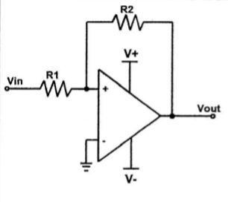

Figure 1: Diagram of Set Up for Task 1

**Task 1.1:**

Figure 1 matches these expressions found in the textbook:

V(TH) = -(L-)(R1/R2) [Equation 13.30 from Sedra & Smith]

V(TL) = -(L+)(R1/R2) [Equation 13.29 from Sedra & Smith]

Equations 1&2: V(TH) and V(TL) equations

**Task 1.2:**

As given in the lab, L+ = 15V and L- = -15V. For V(TH) = 3V:

R1/R2 = -V(TH)/(L-) = -(-15V)/(3V) = 5

Derived from Equation 1

We can pick any resistance as long as R1/R2 = 5, for example 1k-ohms and 5k-ohms. Due to availability of resistors in the lab, the lab TA recommended 1k-ohms and 5.1k-ohms to be used as R1 and R2 respectively.

**Task 1.3:**

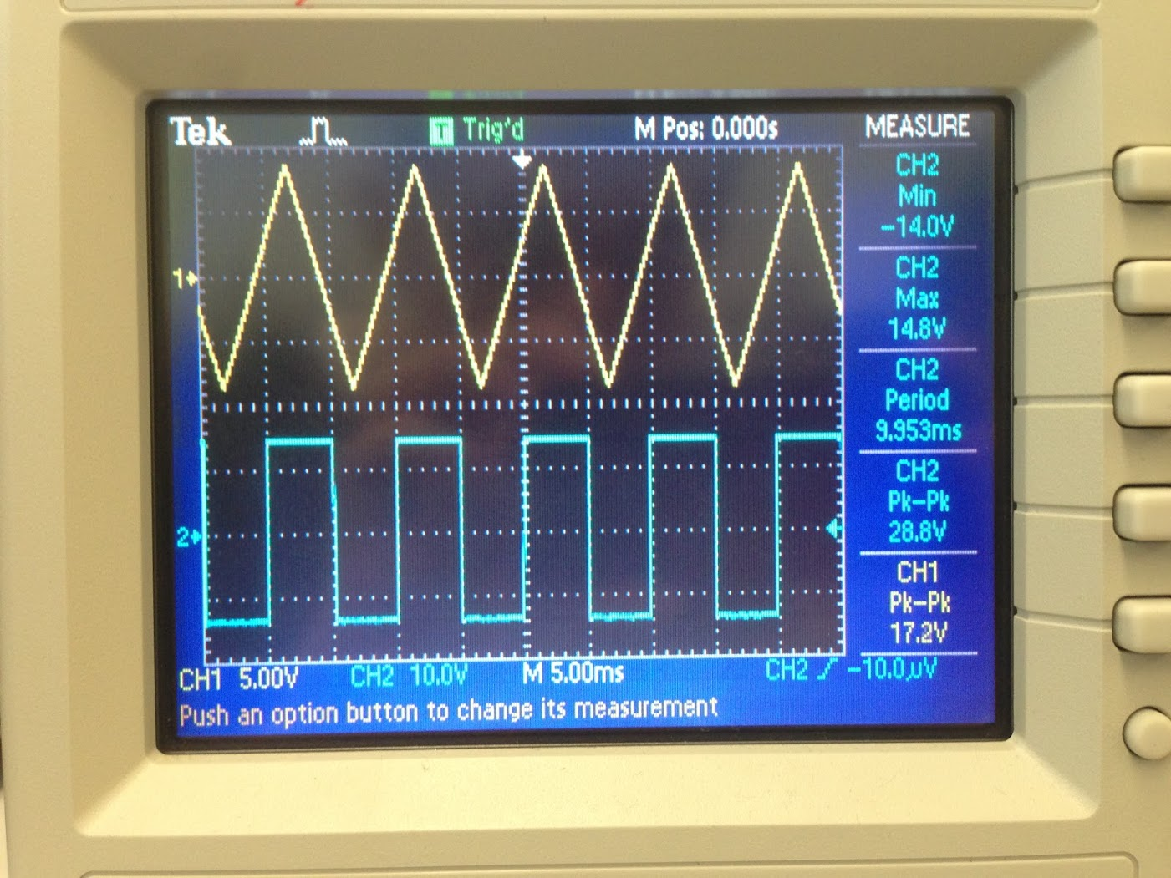

Figure 2: CH1 as Vin, CH2 as Vout

Note that due to imprecision of the apparatus knob, we couldn’t get to to 16V exactly (hence the Vpp = 17.2V shown).

**Task 1.4:**

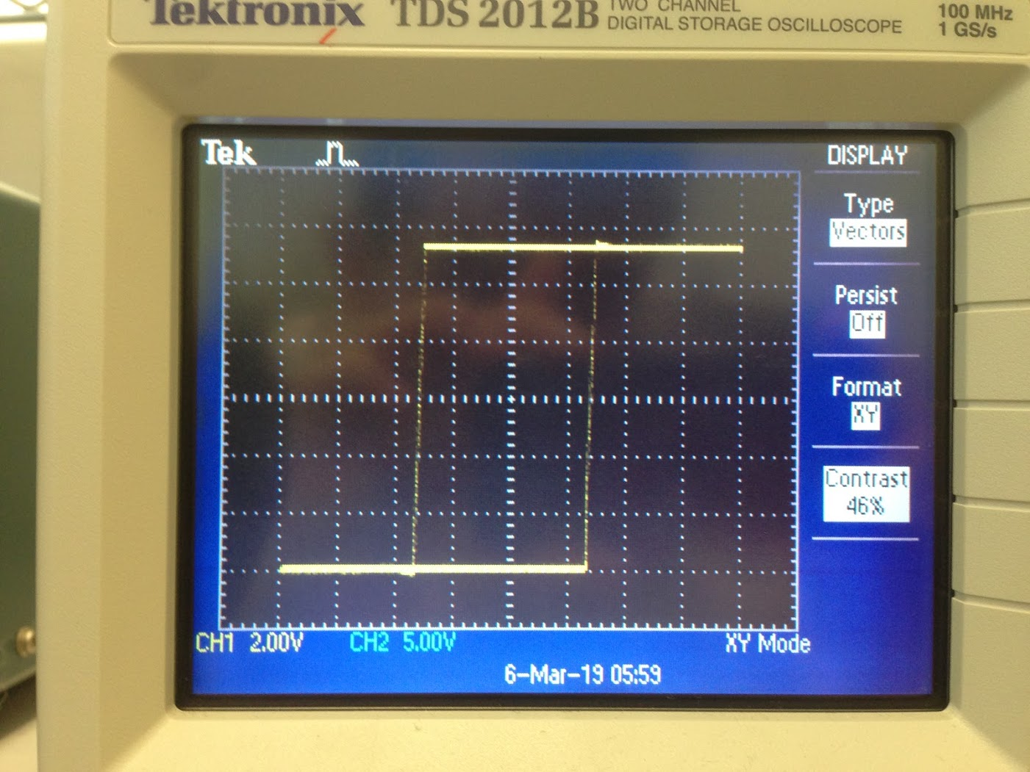

Figure 3: Hysteresis Loop at Minimum Value of Vin,pp, at Approximately 5.92V

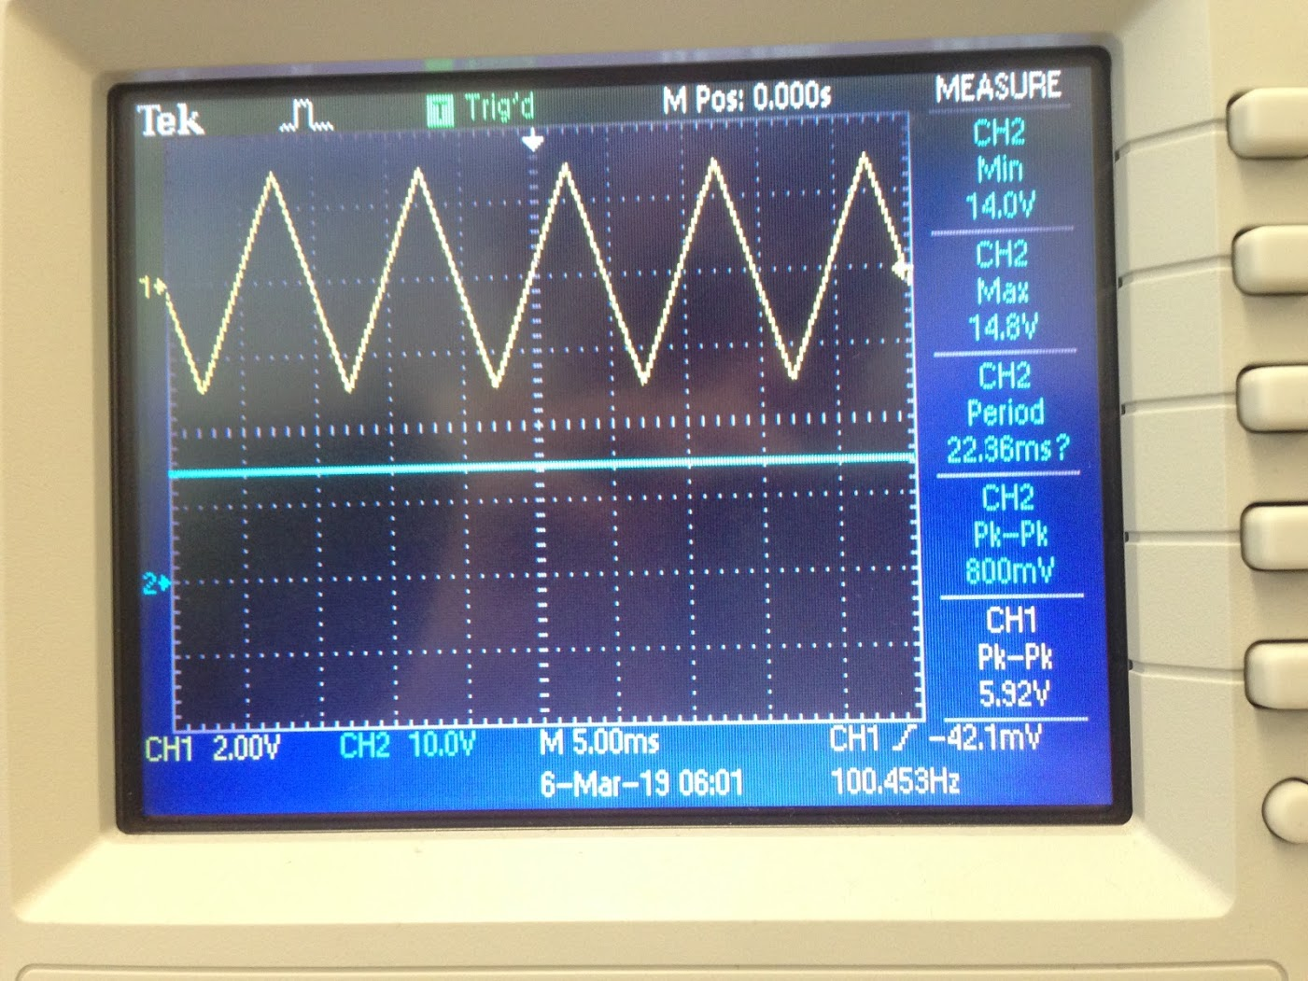

Figure 4: Vin and Vout Plot of Time at the Minimum Vin Value for Hysteresis Loop

Triggering by hand, the minimum Vin,pp that triggers hysteresis loop is 5.92V.

**Task 1.5:**

Similar to Figure 3, hysteresis loop can be plotted as:

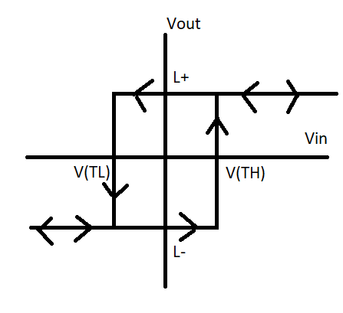

Figure 5: DC Transfer Characteristic of Schmitt Trigger

L+, L-, V(TH), and V(TL) were measured on the oscilloscope according to these figures:

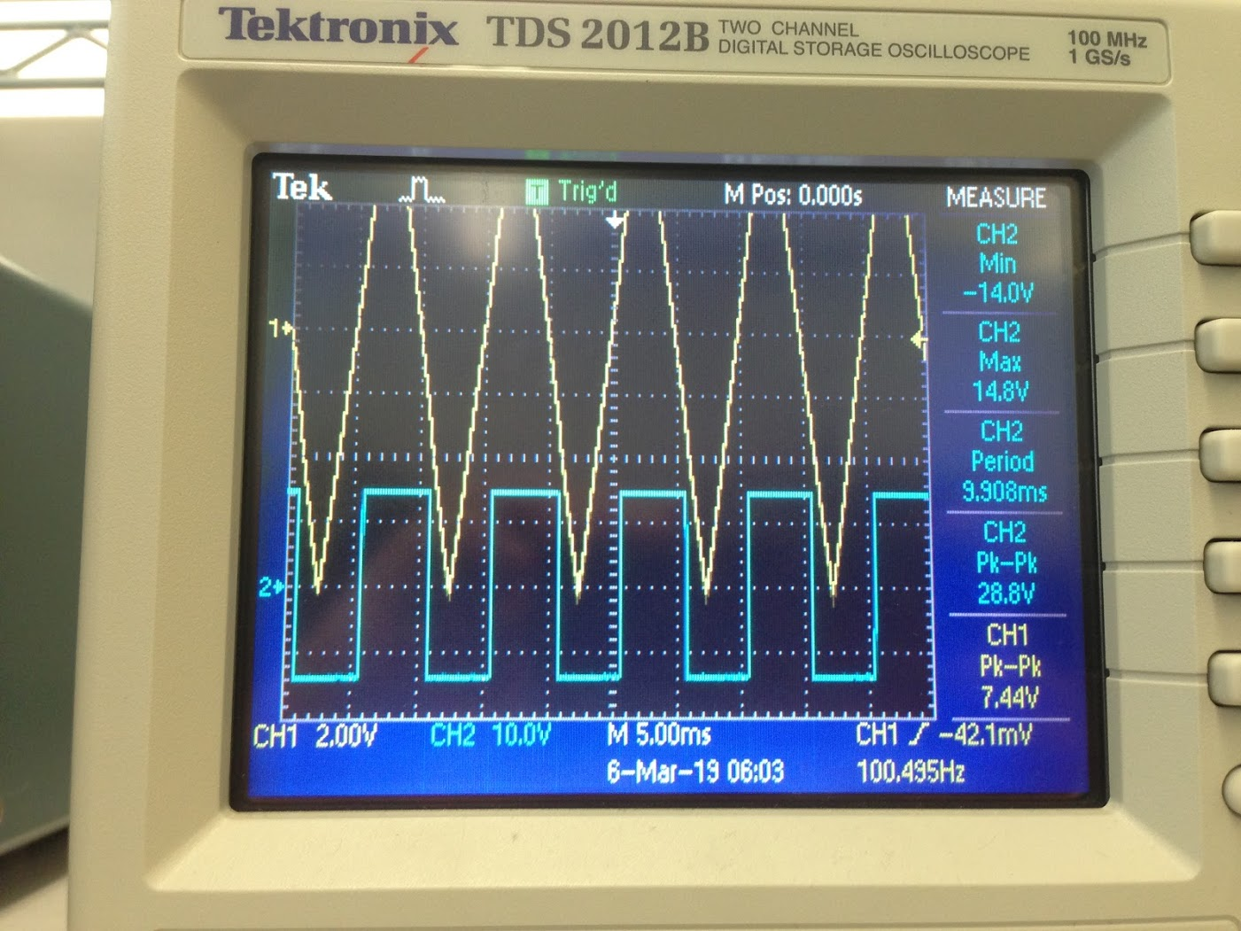

Figure 6: Saturated Input Voltage Measurement Plot; Note that Vin(sat) = L+, L-

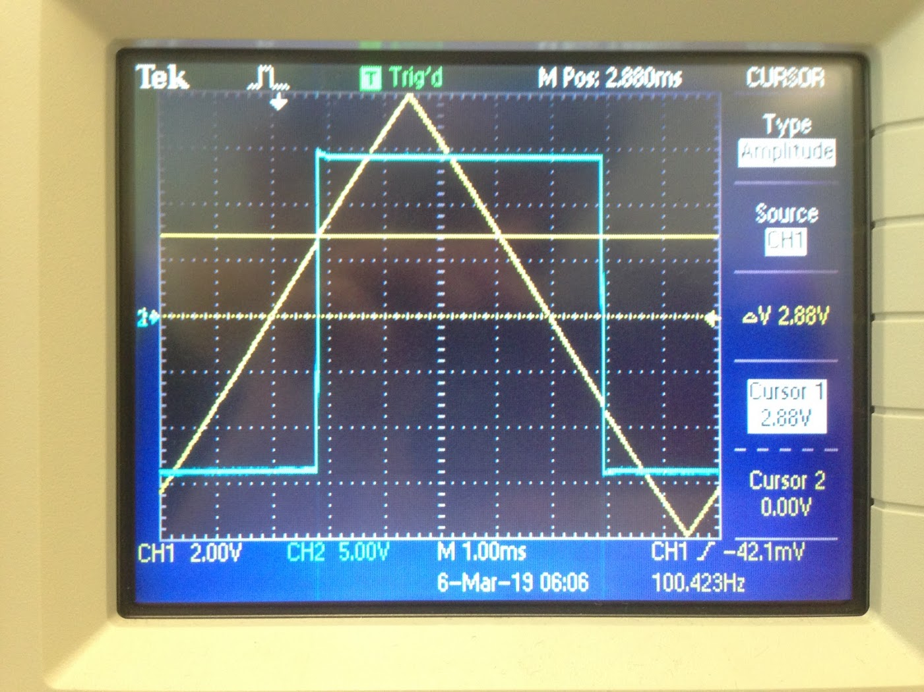

Figure 7: V(TH) Measurement Plot

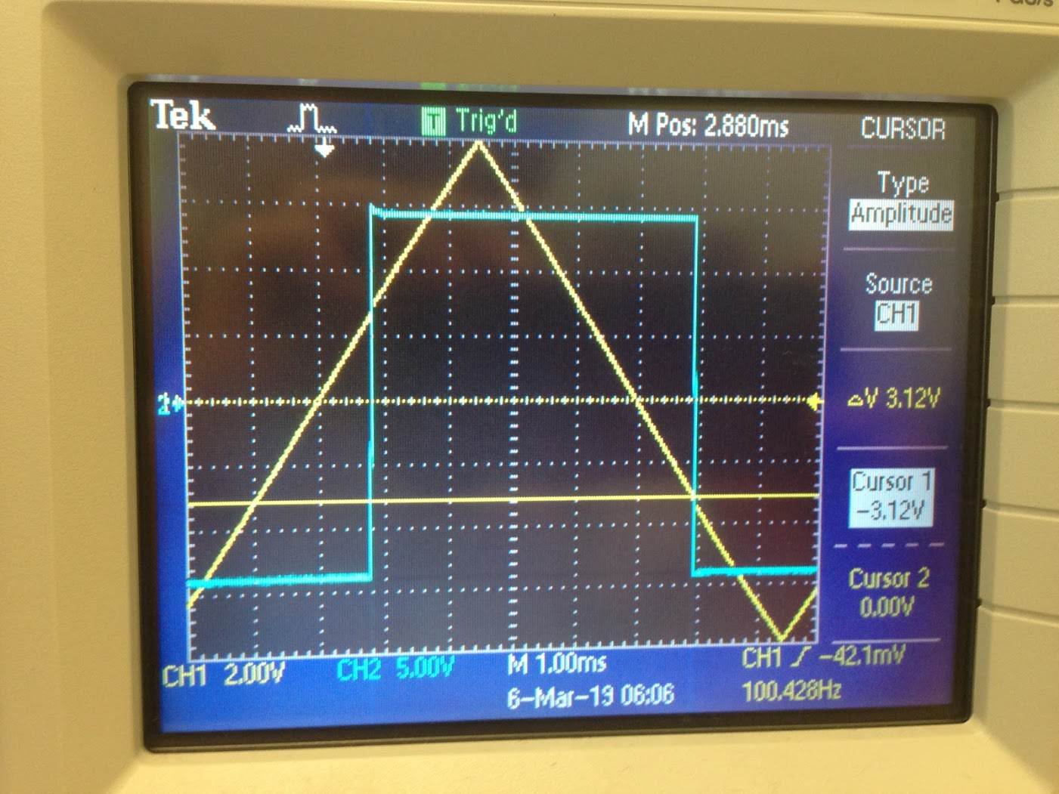

Figure 8: V(TL) Measurement Plot

|  |  |  |
| --- | --- | --- |
|  | Theoretical | Measured |
| L+ | 15V | 14.8V |
| L- | -15V | -14V |
| R1 | 1k-ohms | 1k-ohms |
| R2 | 5k-ohms | 5.1k-ohms |
| V(TH) | 3V | 2.88V |
| V(TL) | -3V | -3.12V |

Table 1: Theoretical vs Measured Values from Task 1

Comparing theoretical and measured L+, L-, V(TH), and V(TL), we can see that measured value are lower than theoretical values across all four. Discrepancies arise from the real losses not accounted for in theoretical calculations. As noted in pointer T1.2 from lab manual, saturation voltage of op amp is +/-14V with power supply of 15V, so our discrepancies in the L+ and L- are approximate as expected:

L+, expected = 14V ≃ L+, measured = 14.8V

L-, expected = -14V ≃ L-, measured = -14V

Additionally, the resistors we used did not perfectly match theoretical calculations. We used a larger R2, so according to Equation 1&2, it is expected that V(TH) and V(TL):

V(TH) = -(L-)(R1/R2) = -(-14V)(1k-ohms/5.1k-ohms) = 2.74V ≃ 2.88V

V(TL) = -(L+)(R1/R2) = -(14.8V)(1k-ohms/5.1k-ohms) = -2.90V ≃ -3.12V

V(TH), theoretical = 3V > V(TH), measured = 2.88V

V(TL), theoretical = -3V > V(TL), measured = -3.12V

**Task 2:**

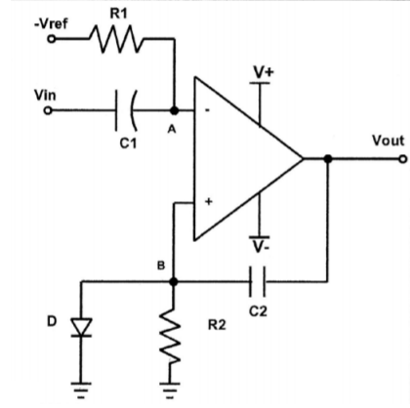

Figure 9: Diagram of Set Up

**Task 2.1:**

From the prelab, we have found that:

T = C2R2ln((V- - V+)/Vref)

Equation 3: Pulse Equation for Specified Circuit

Due to lab equipment availability, the lab TA recommended R1 = 220ohms, C1 = 0.68μF, R2 = 33k-ohms, and C2 = 100μF. Also considering that V- = -15V, and V+ = 15V, we should pick Vref to get T = 1ms.

1ms = 33k-ohms * 100μF * ln((-15V - 15V)/Vref)

Vref = -29.99V

**Task 2.2:**

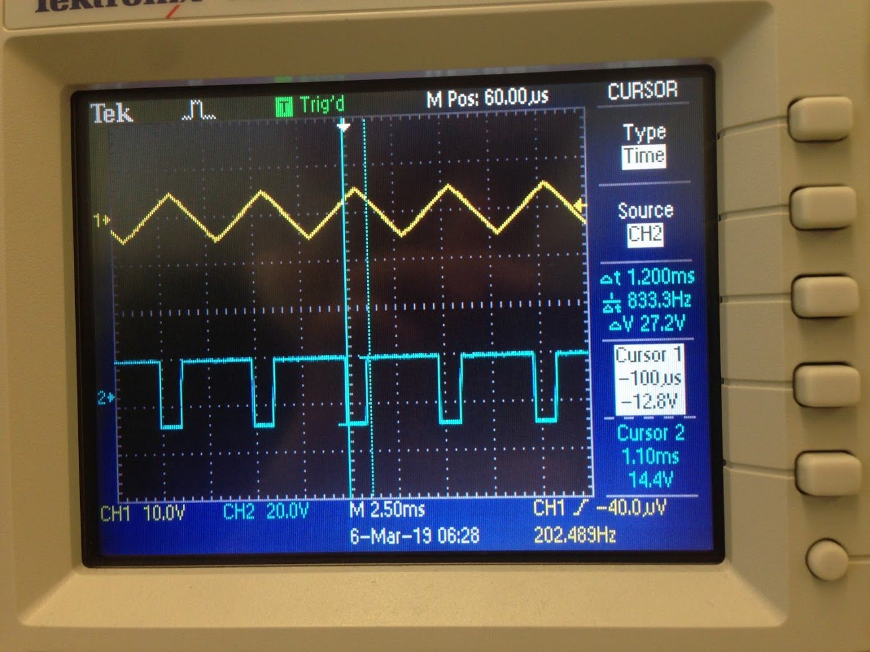

Figure 10: CH1 as Vin, CH2 as Vout, at f ≃ 200Hz, Vpp ≃ 10V

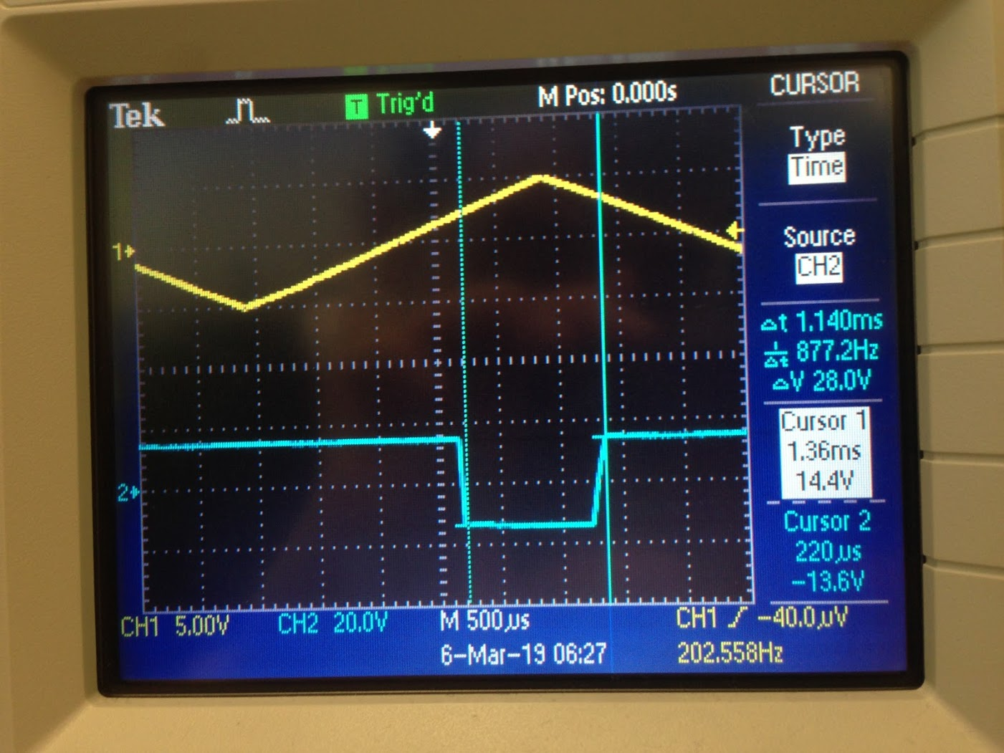

Figure 11: Time Pulse of Figure 10 Measurement

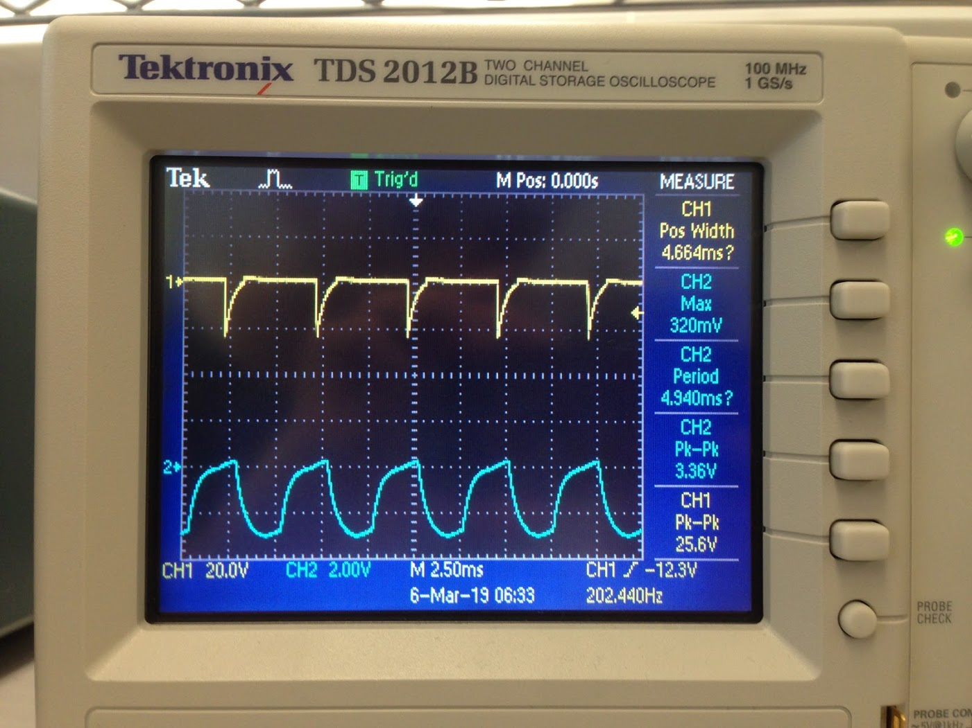

Figure 12: CH1 as VB, CH2 as VA

**Task 2.3:**

Compared to predicted pulse width, 1ms, the real time pulse from Figure 11 is 1.140ms. This discrepancies is because we couldn’t scroll the knob precisely enough to get to 1ms; 1.140ms was the closest we could do.

**Task 2.4:**

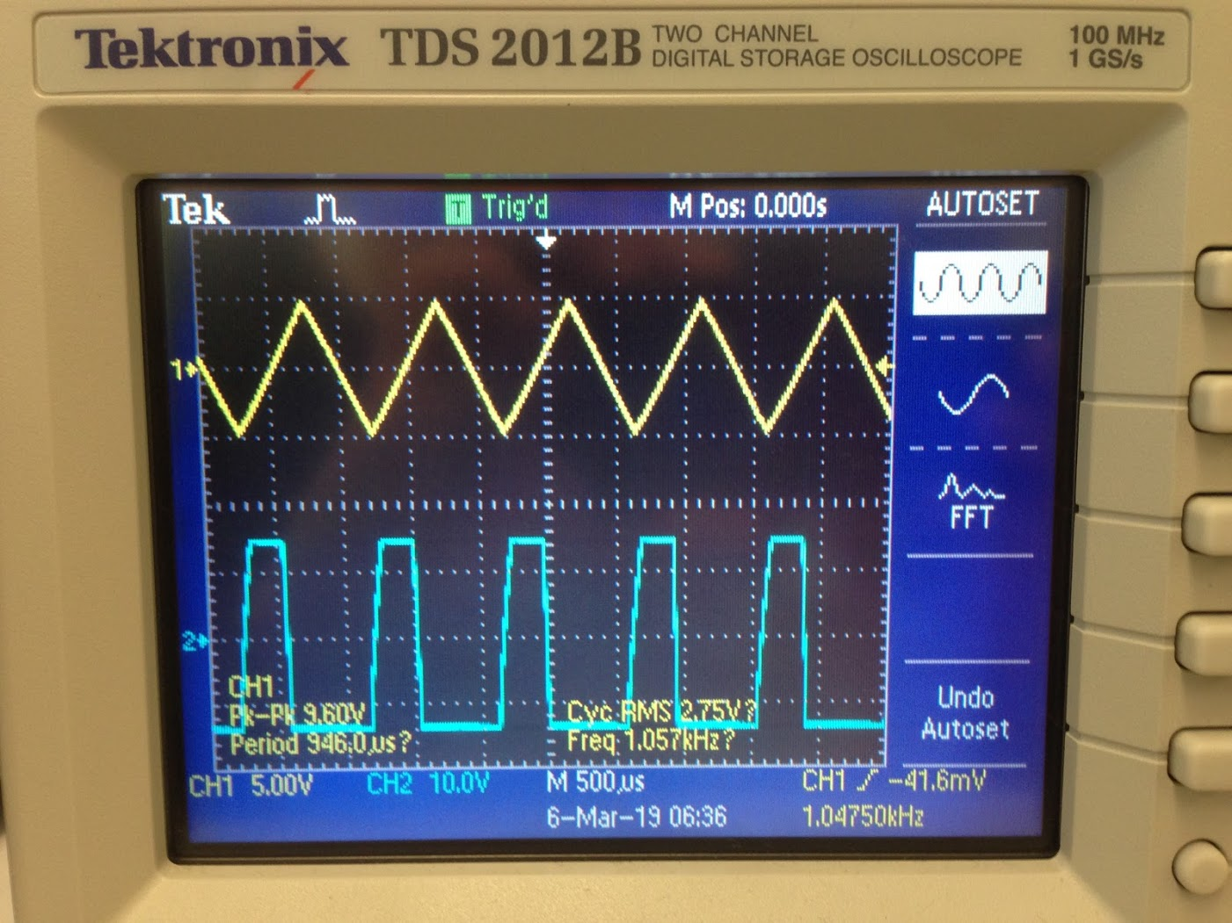

Figure 13: CH1 as Vin, CH2 as Vout, at f ≃ 1000Hz, Vpp ≃ 10V

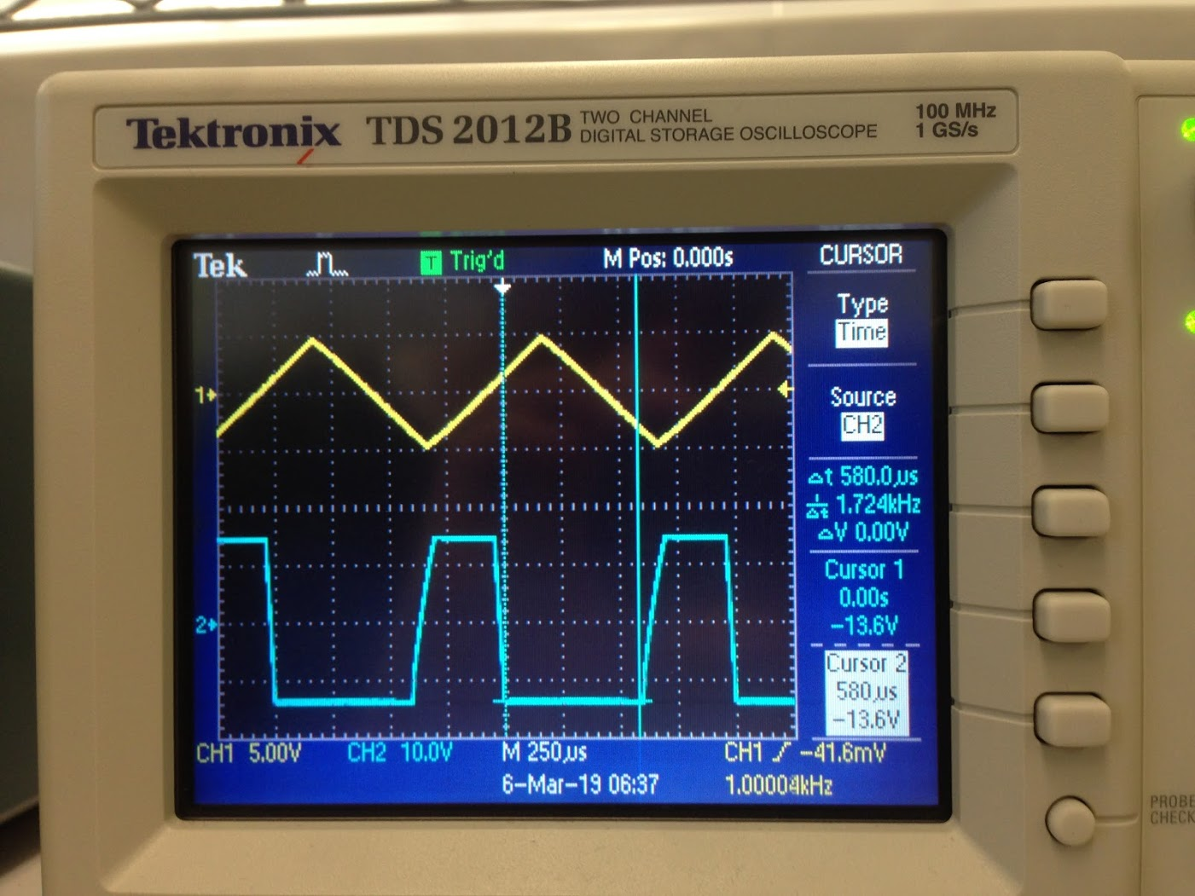

Figure 14: Time Pulse of Figure 13 Measurement

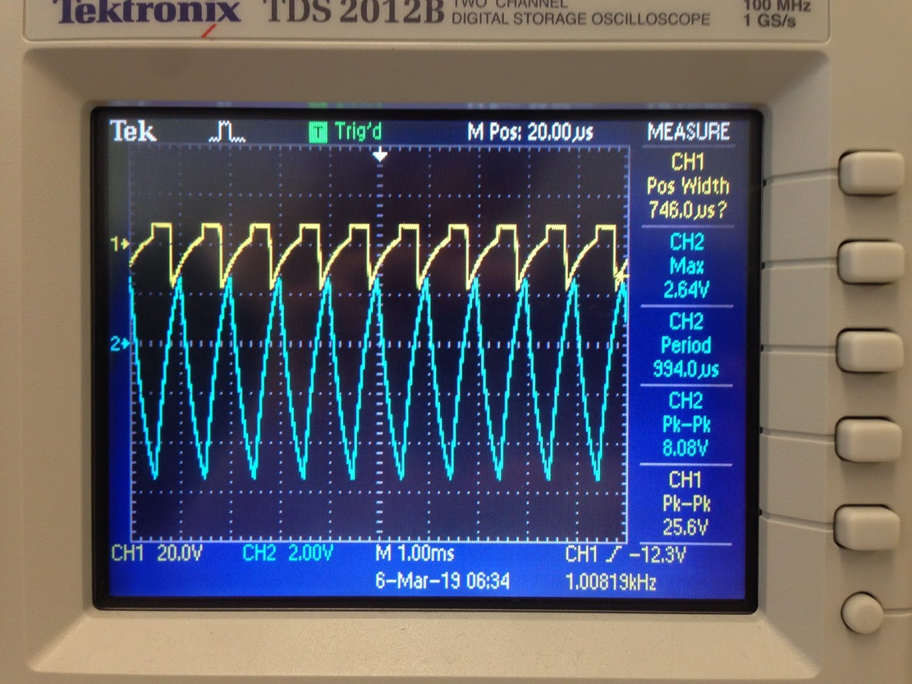

Figure 15: CH1 as VB, CH2 as VA

The time pulse as shown in Figure 14 is 0.000580ms. Further increasing the frequency could lead to could lead to Vout skipping pulses and not flipping according to Vin. This could because the frequency is too high, and there is not enough time for VA to reach Vref and trigger VB to switch to VD value.